
DATABASE AND MANAGEMENT SYSTEM
PROJECT REPORT

Name: Ilham Nawaz
ID: 40089

Department:
BS(Cs)
Summited to:
Sir Waseem Malik

Task 1: Project Report (Documentation)
1. Introduction
The E-Learning Platform Database Management System is a comprehensive web-based application designed to manage online courses, student enrollments, instructor management, assignments, submissions, and payment processing. This system provides a complete solution for educational institutions to conduct online learning programs efficiently.
2. Purpose of the Project
The primary purpose of this project is to:
- Demonstrate practical implementation of database management concepts
- Create a functional e-learning platform with role-based access
- Implement CRUD operations using PHP and MySQL
- Showcase database design principles including normalization and relationships
- Provide a foundation for real-world e-learning applications
3. Scope of the Project
The project scope includes:
- User Management: Student, Instructor, and Administrator registration and authentication
- Course Management: Create, read, update, delete courses with modules and content
- Enrollment System: Course enrollment with progress tracking
- Assignment Management: Assignment creation, submission, and grading
- Payment Processing: Course fee payment tracking
- Reporting: Administrative reports and analytics
- Discussion Forums: Student-instructor communication
4. Tools & Technologies
Development Tools:
- XAMPP 8.2.4 - Local server environment (Apache, MySQL, PHP)
- Visual Studio Code - Code editor
- phpMyAdmin - Database management tool
- MySQL Workbench - Database design tool
5. ERD:
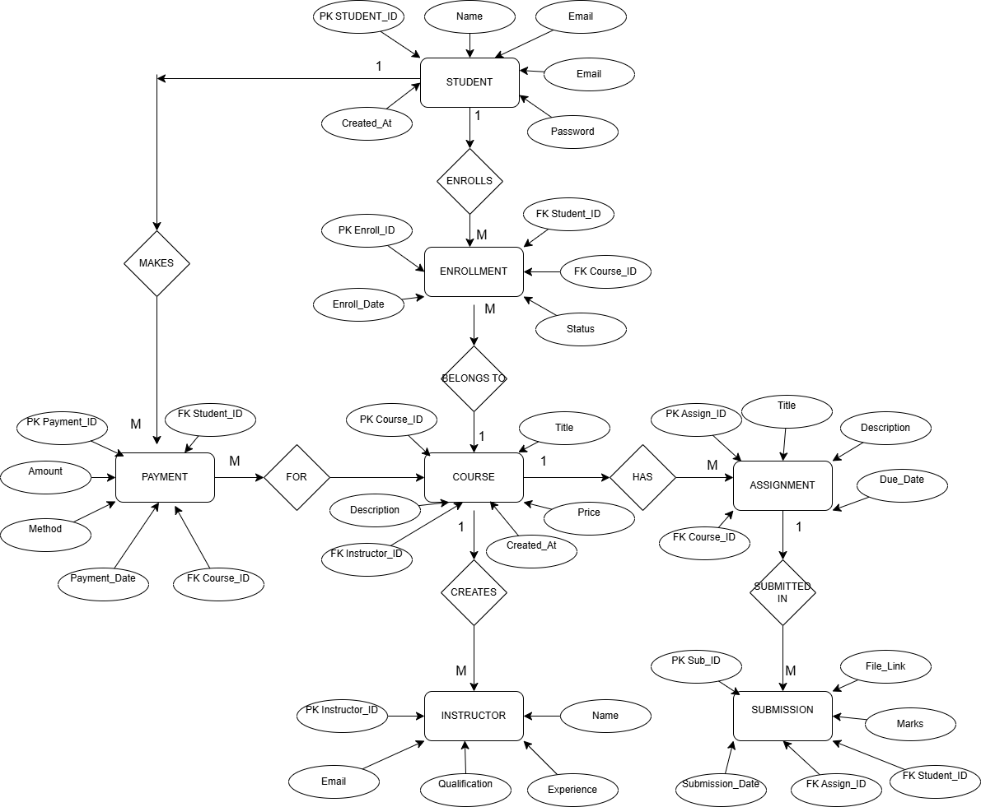
6. Cardinality & Participation:

Relationship | Cardinality | Participation
Instructor → Course | 1 : M | Total
Student → Enrollment | 1 : M | Total
Course → Enrollment | 1 : M | Total
Student ↔ Course | M : N | Via ENROLLMENT
Course → Assignment | 1 : M | Total
Assignment → Submission | 1 : M | Partial
Student → Submission | 1 : M | Partial
Student → Payment | 1 : M | Partial
Course → Payment | 1 : M | Partial

7. Logical Schema
STUDENT
Student_ID | Name | Email | Phone
1 | Sara Khan | sara@gmail.com | 03001234567

INSTRUCTOR
Instructor_ID | Name | Email | Qualification
10 | Sir Waseem | waseem@gmail.com | MS CS

COURSE
Course_ID | Title | Description | Price | Instructor_ID
101 | DBMS | Database Concepts | 5000 | 10

ENROLLMENT
Enroll_ID | Student_ID | Course_ID | Enroll_Date | Status
1 | 1 | 101 | 2025-01-01 | Active

ASSIGNMENT
Assign_ID | Title | Description | Due_Date | Course_ID
201 | ERD Design | Draw ERD | 2025-02-01 | 101

SUBMISSION
Sub_ID | Student_ID | Assign_ID | File_Link | Marks
301 | 1 | 201 | erd.pdf | 85

PAYMENT
Payment_ID | Student_ID | Course_ID | Amount | Payment_Date | Method
401 | 1 | 101 | 5000 | 2025-01-01 | Cash

7. Database Design Explanation
7.1 Normalization Applied
First Normal Form (1NF):
- All tables have primary keys
- All columns contain atomic values
- No repeating groups
Second Normal Form (2NF):
- All tables are in 1NF
- All non-key attributes fully dependent on primary keys
- Example: In ENROLLMENT table, all attributes depend on Enroll_ID
Third Normal Form (3NF):
- All tables are in 2NF
- No transitive dependencies
- Example: Student address doesn't affect enrollment status
7.2 Database Tables Overview
Table Name | Purpose | Records (Sample)
student | Store student information | 9
instructor | Store instructor details | 4
course | Course catalog | 5
enrollment | Student-course relationships | 11
assignment | Course assignments | 7
submission | Assignment submissions | 7
payment | Payment transactions | 9
quiz | Course quizzes | 3
discussion | Forum discussions | 3
admin | Administrator accounts | 2
certificate | Course certificates | 1







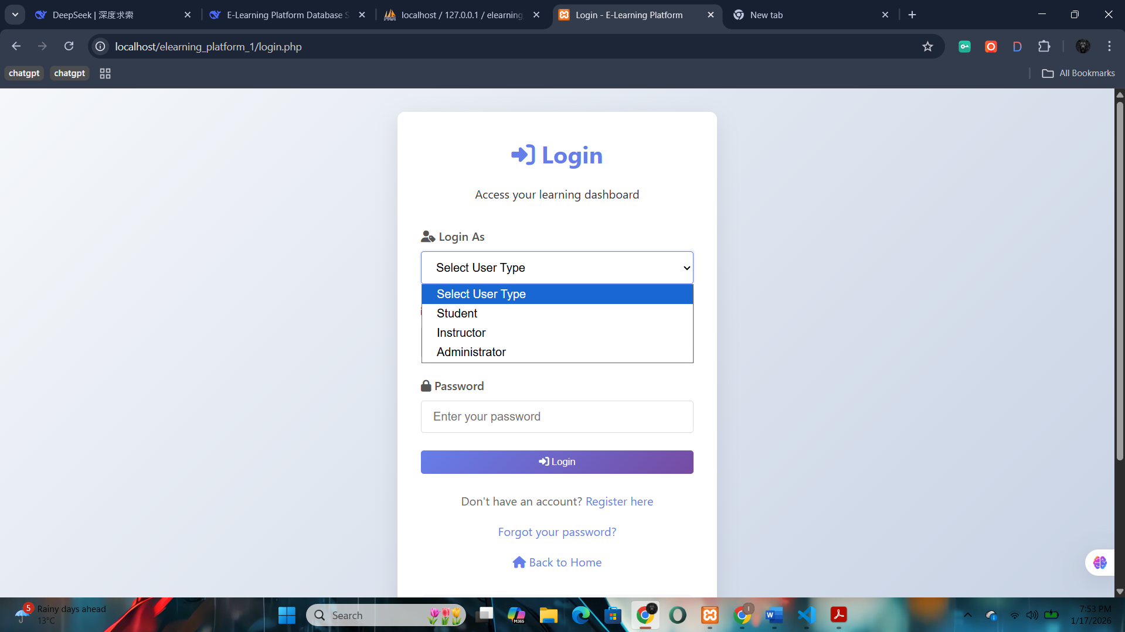

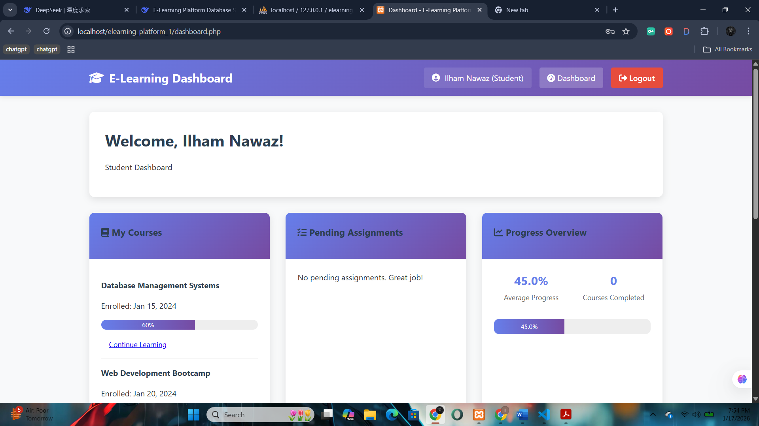

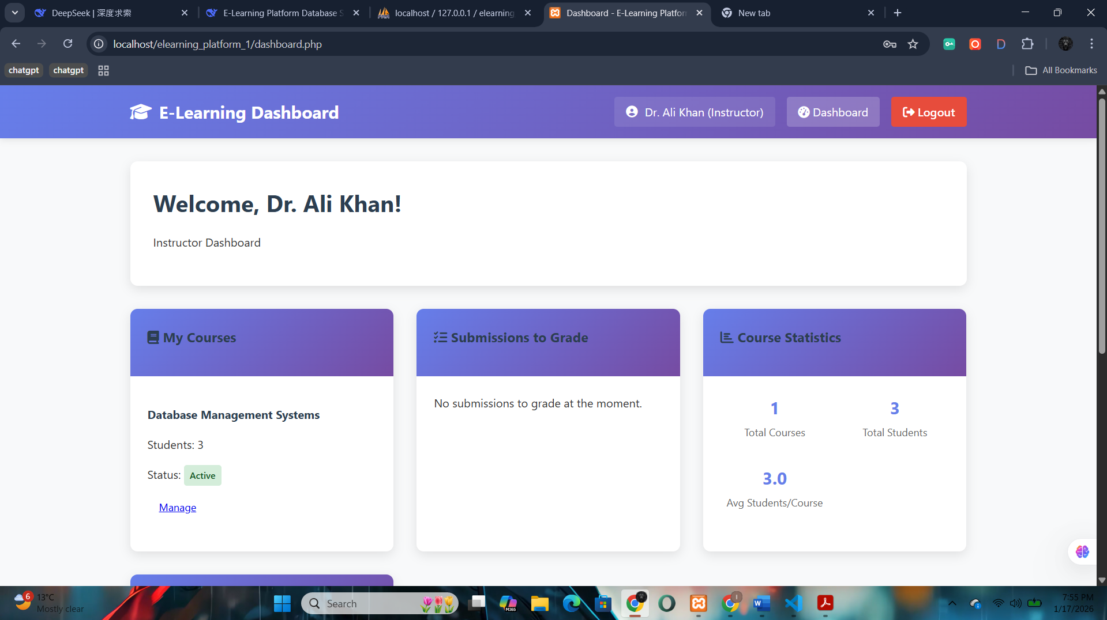

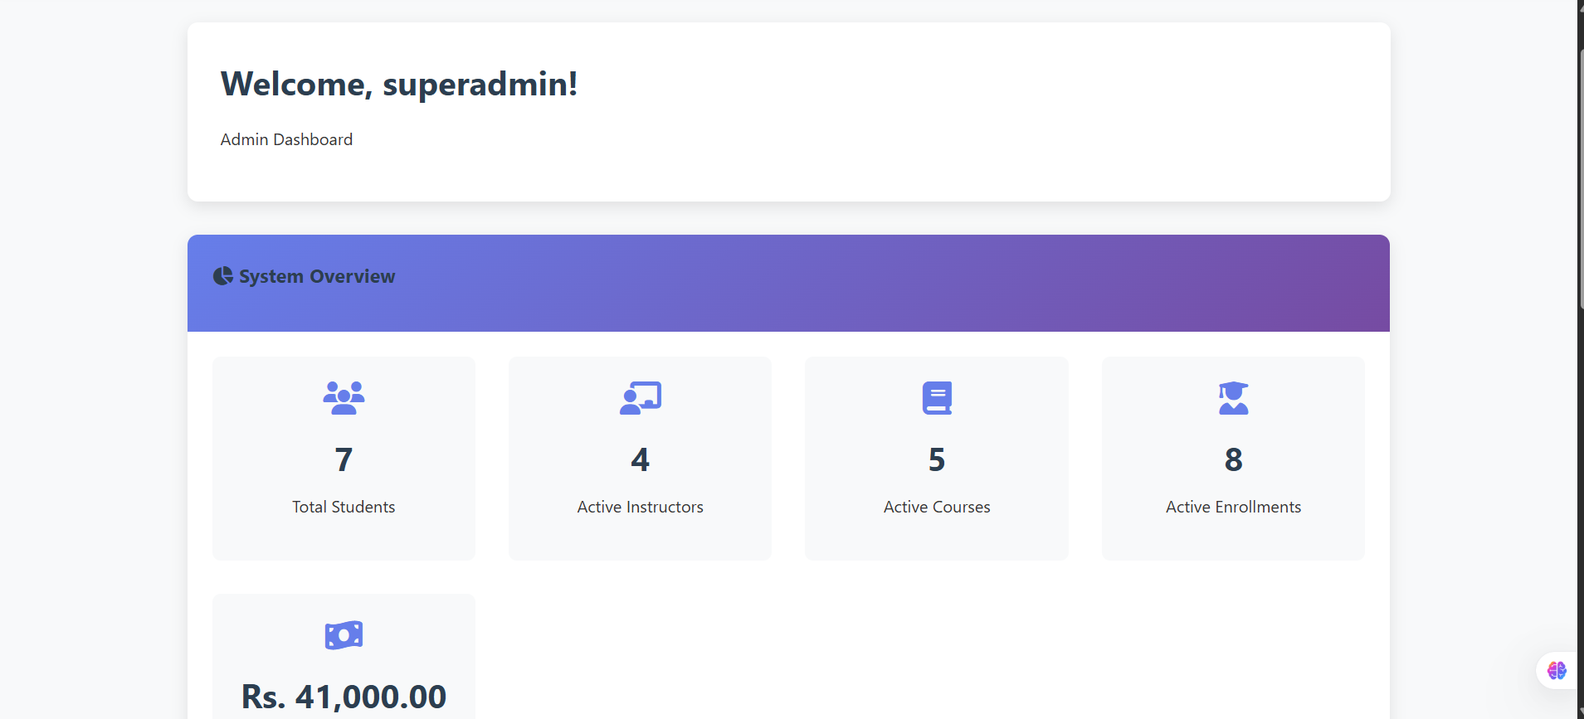

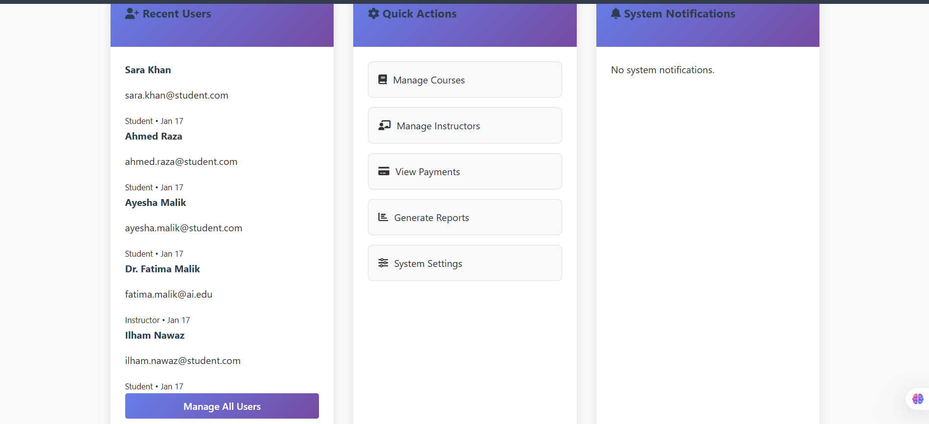

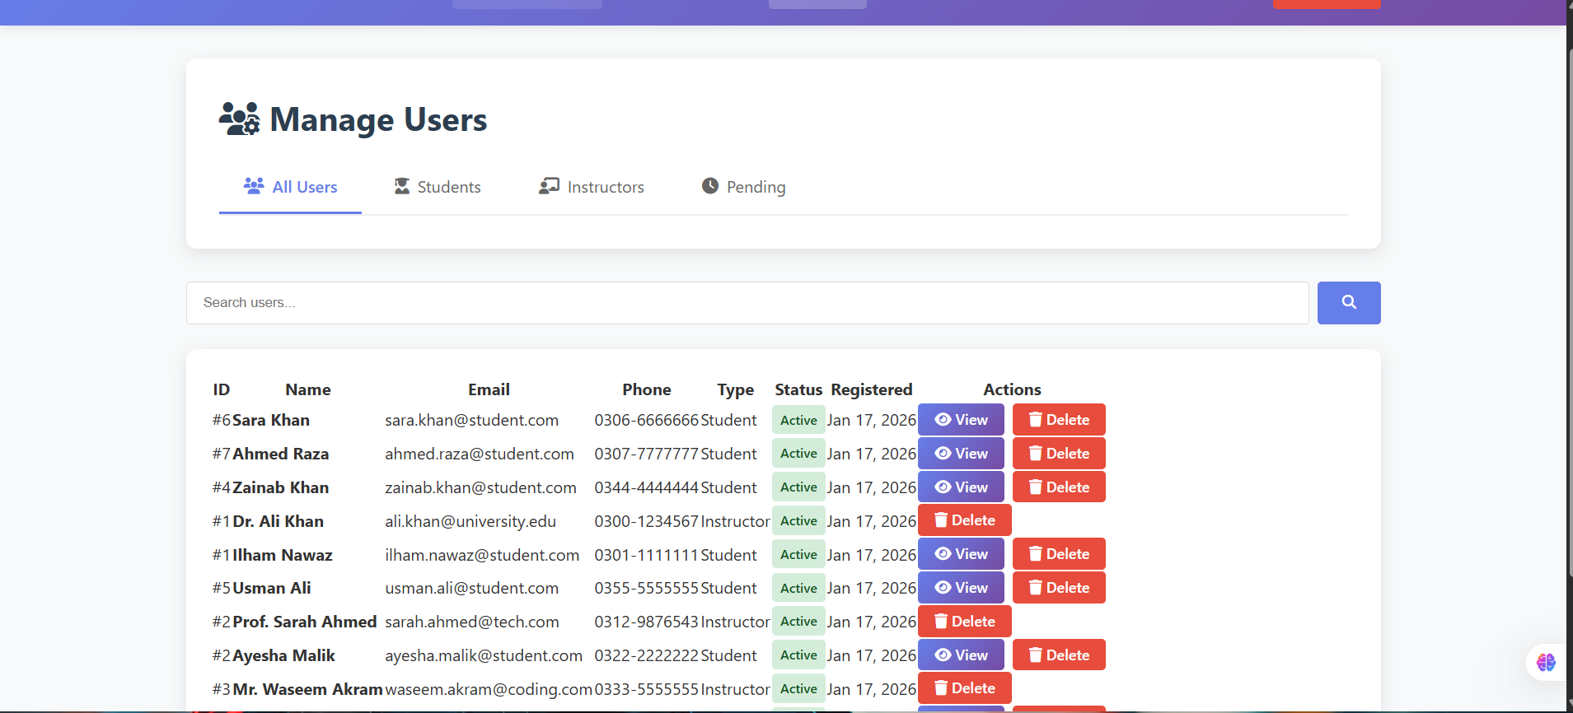

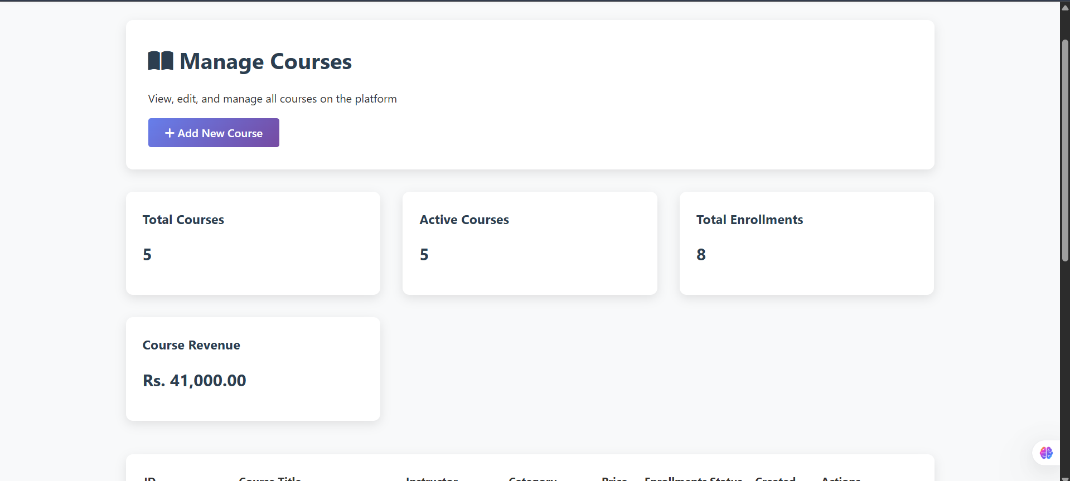

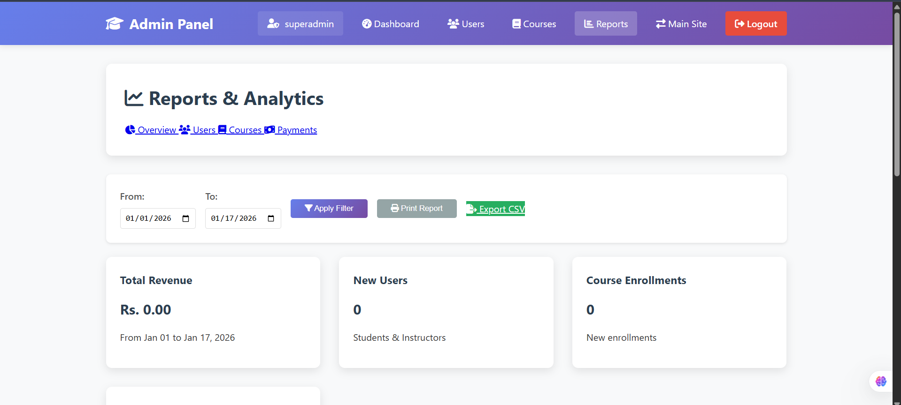



9. Conclusion
The E-Learning Platform Database Management System successfully implements all required features and demonstrates comprehensive understanding of database concepts. The project:
Meets all technical requirements specified in the task
Implements complete CRUD operations using PHP and MySQL
Demonstrates proper database design with normalization
Provides functional user interfaces for all roles
Includes comprehensive documentation and working code

Q No.2: Technical Requirements



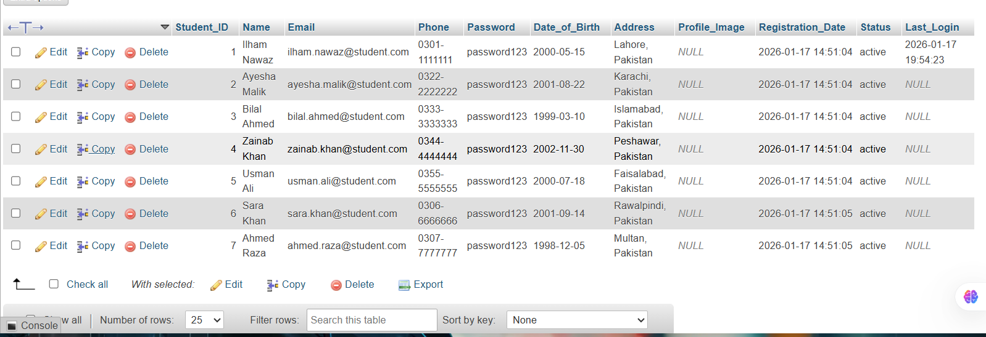

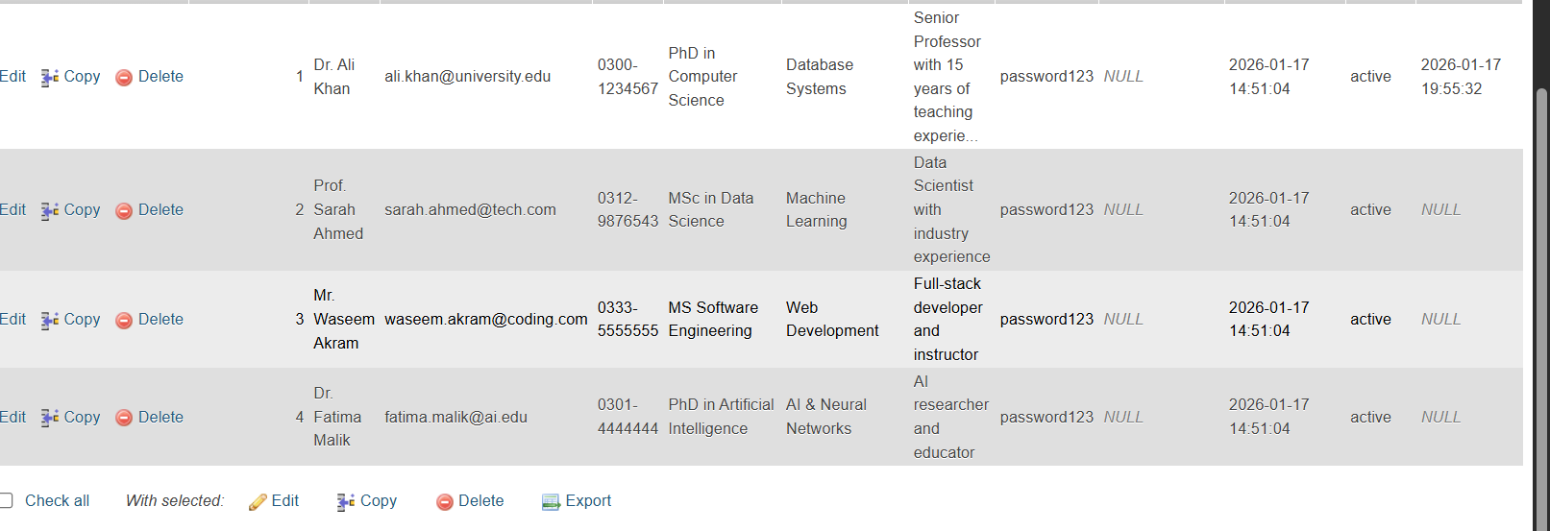

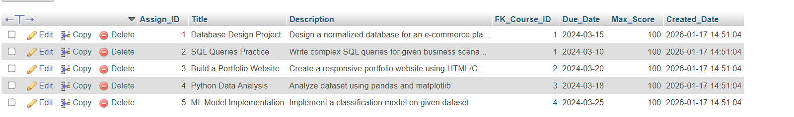



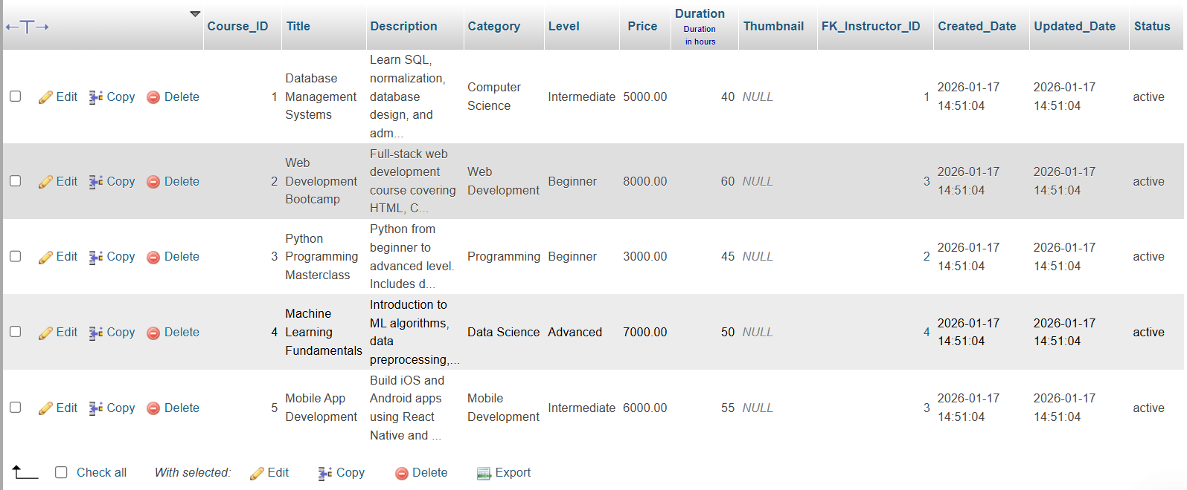

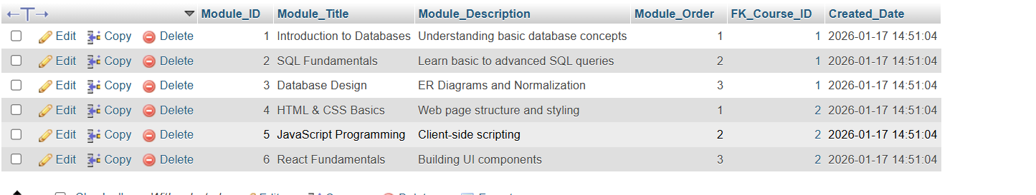

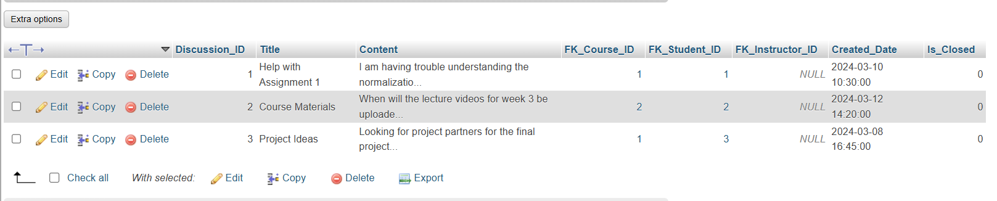

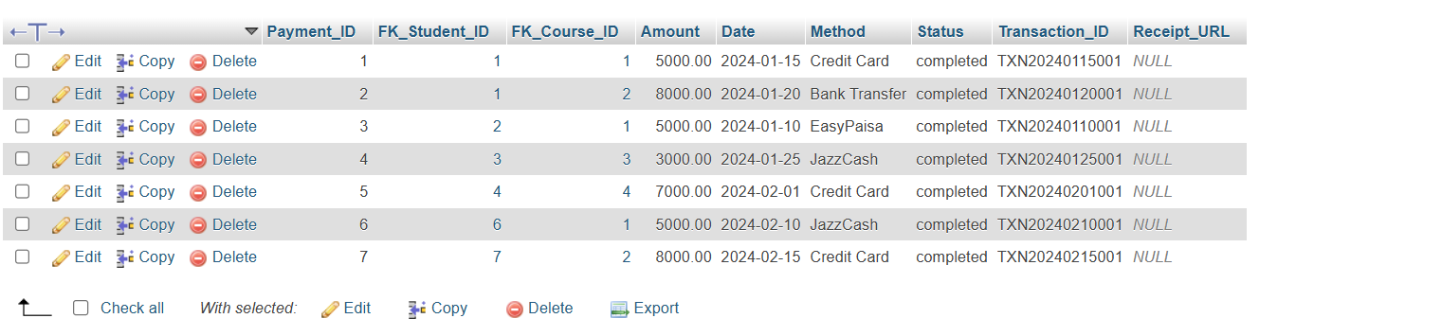

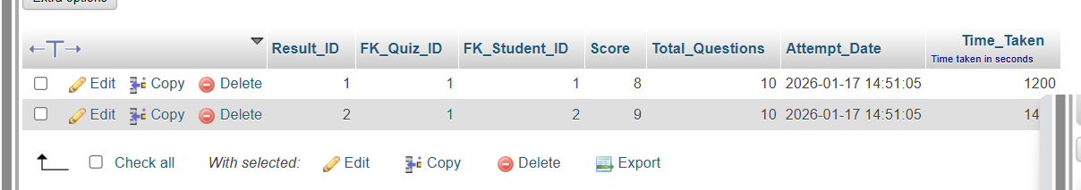

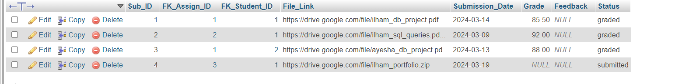

Task.No.2: CRUDE operations:

• UPDATE & DELETE
SELECT * FROM Student;
SELECT * FROM Instructor;
SELECT * FROM Course;
SELECT * FROM Enrollment;
SELECT * FROM Assignment;
SELECT * FROM Submission;
SELECT * FROM Payment;
GO

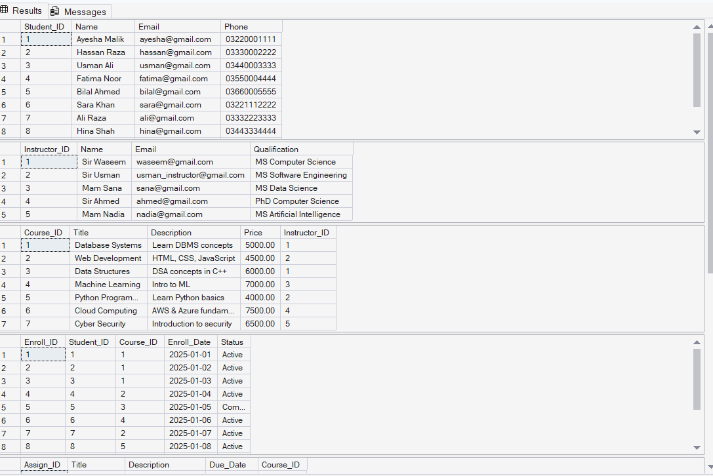

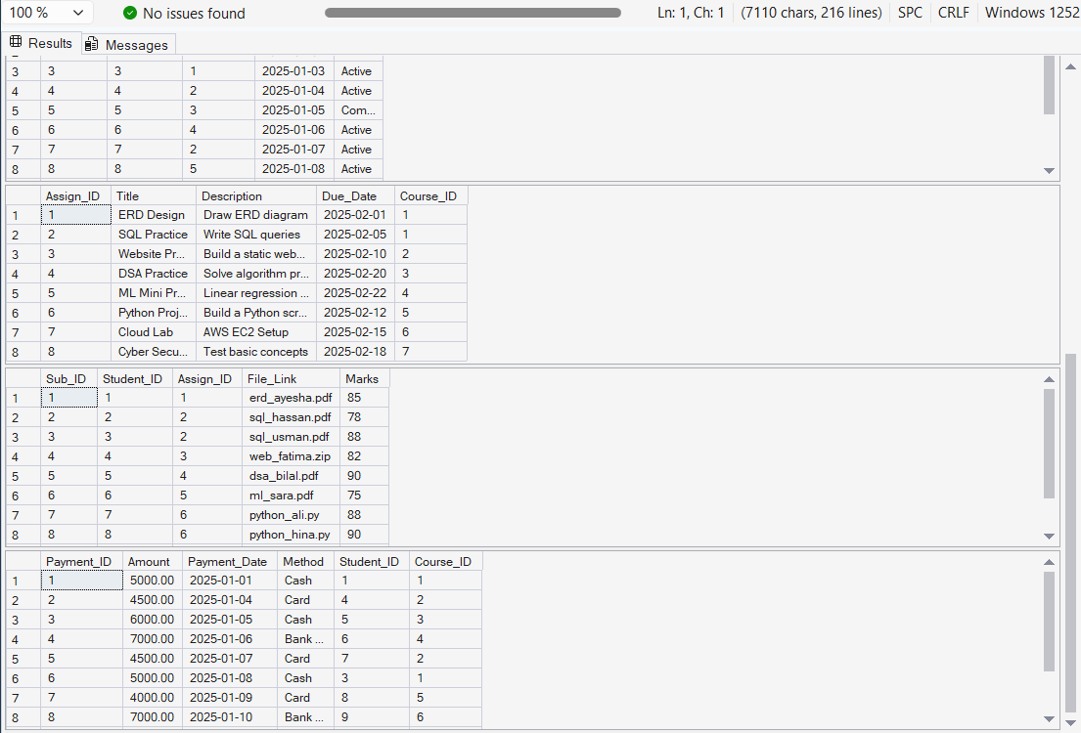

/*SELECT Queries*/
SELECT Title, Price FROM Course;

SELECT Name, Email, Qualification FROM Instructor;

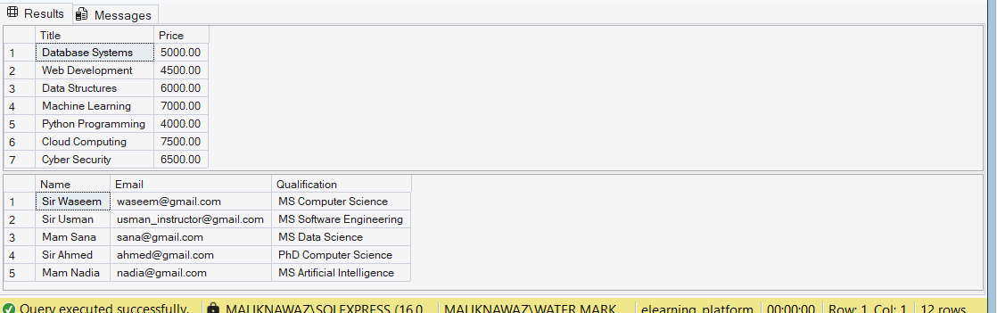

/*UPDATE*/
UPDATE Student
SET Phone = '03001112222'
WHERE Name = 'Ayesha Malik';

UPDATE Course
SET Price = 5500
WHERE Title = 'Database Systems';
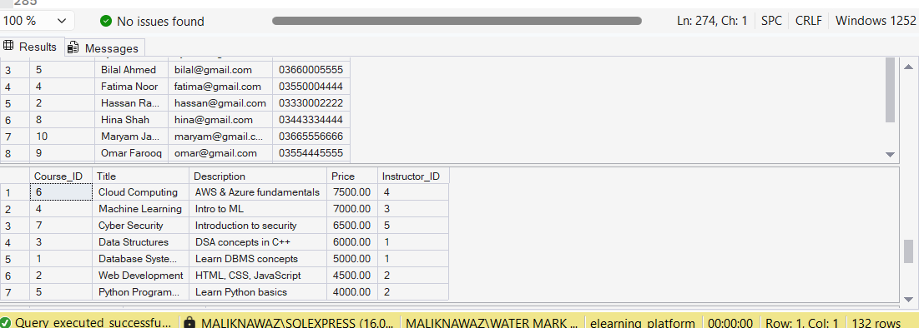

/*DELETE*/

SELECT * FROM Payment

DELETE FROM Payment
WHERE Student_ID = 5;

DELETE FROM Submission
WHERE Student_ID = 5;

DELETE FROM Enrollment
WHERE Student_ID = 5;

DELETE FROM Student
WHERE Student_ID = 5;

SELECT * FROM Payment

